|  |  |
| --- | --- |
| El-Shorouk Academy The Higher Institute of Engineering | |
| Computer and control engineering | |
| Third Year | Electromagnetic Waves |
| First Semester 2023 | |

**Sheet (1) : Optical Fiber**

[1]Consider a certain optical fiber cable has an fiber attenuation coefficient of 1.5 dB/km at operating wavelength 1300 nm. If 0.5 mW of input optical power is initially launched at the transmitter into the optical fiber. What is the output optical power level at the receiver in microwatts, If the distance between transmitter and receiver is 8 km. The communication path is made by splicing similar optical fiber reels. Each reel has maximum length of 2 km. The losses due to splices average is 0.1 dB per splice. The input coupling loss (ICL) is 1 dB while the output coupling loss (OCL) is 2 dB.

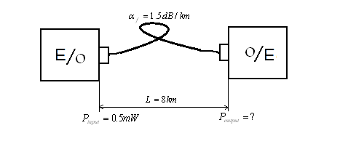

…………………………………………………………………………………………..…..…...

[2] An optical signal has lost 55 percent of its power after transmitting through L=3.5 km of optical fiber communication link between a transmitter and a receiver. What is the fiber loss coefficient in dB/km in this optical fiber cable?. If the communication path is made by splicing similar optical fiber reels. Each reel has maximum length of 3 km. The losses due to splices average is 0.2 dB per splice. The input coupling loss (ICL) is 1 dB while the output coupling loss (OCL) is 0.8 dB. .

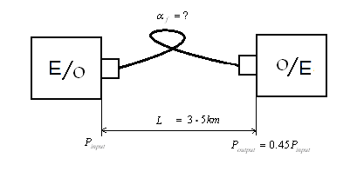

…………………………………………………………………………………………………

[3] Consider an optical fiber has an attenuation coefficient of 0.5 dB /km at operating wave length 1.55 um. If 1 mW of input optical power is initially launched into the optical fiber by the transmitter and the output optical power level of 0.1m W at the receiver. What is the fiber length? . Assuming the splice loss, the input coupling loss (ICL) and the output coupling loss (OCL) is ignored.

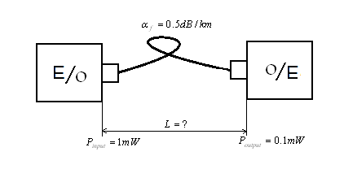

………………………………………………………………………………………………..…

[4] Consider 12 km long optical fiber link between transmitter and receiver has a fiber loss coefficient  1.5 dB /km. What is the required input optical power level that must be launched by the transmitter into the fiber to get an output optical power level of 0.3 uW at the receiving end?. Assuming the communication path is made by splicing similar optical fiber reels. Each reel has maximum length of 3 km. The losses due to splices average is 0.1 dB per splice. The coupling losses are 2 dB at each transmit and receive end.

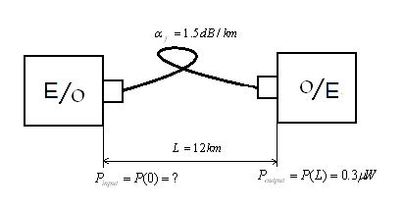

……………………………………..……………………….……………………….………..…

[5] Consider a 50/125 step index (SI) optical fiber with n1=1.48 and n2=1.465 that is used at operating wave length =1320 nm. Determine the following:

(i) The numerical aperture (NA). (ii)The acceptable angle. (iii)The number of modes the fiber will support.(iv) The fractional power propagating in the cladding.

(v) The core diameter such that step index (SI) fiber supports a single mode(SM).

………………………………………………………………………………………………….

[6] Consider step index (SI) fiber having a core radius of a= 25 um, a core refractive index of n1= 1.48 and index difference =0.01 and an operating wave length of =0.84um.(i) Find the numerical aperture (NA). (ii) Determine its V number.(iii) How many modes it will support. (iv) Determine the fractional power propagating in the cladding.

…………………………………………………….……………………………………………… [7] A single mode (SM) fiber is made with a core diameter d=10 um and is coupled to light source with wave length =1.3 um assuming the core glass has refractive index n1= 1.55. Determine the following:(i) The cladding refractive index n2 required for producing single mode.(ii) The maximum value of fractional difference index. (iii) The acceptance angle.

…………………………………………………….………………………………………………

[8] An optical fiber core made of glass with refractive index n1=1.55 and its cladding is another glass with refractive index n2=1.51launching from air. The fiber has a core diameter of 50 um and is used at wavelength of  = 0.8um.(i)What numerical aperture (NA) does fiber have? (ii) What is the acceptance angle?(iii)Find its V number. (iv) How many modes it will support.

…………………………………………………………………………………………………

[9] Calculate the number of modes at wave length of 1300nm in a graded index (GI) fiber having profile ( =1) a 50 um core diameter n=1.48 and n=1.46. How does this compare to step index (SI) fiber. What is the percentage of optical power flows in the cladding in each case?

………………………………………………………………………………………………….

[10]Consider step index (SI) fiber having a 50 um core diameter and core refractive index of n1=1.48 and cladding refractive index of n2=1.46. (i) Determine the normalized frequency at wavelength 0.82 um.(ii)How many modes will propagate in the fiber of 0.82 um?.(iii)How many modes will propagate in the fiber at wavelength 1.3 um?. (iv)What percentage of optical power flows in the cladding in each case?

……………………………………………………………………………

[11]A manufacturer wishes to make silica –core step index (SI) optical fiber (O.F.) with a normalized frequency V=75 and a numerical aperture NA=0.30 to be used at wavelength =820nm if the core index n1=1.458. What should the core size (a) and the cladding index (n2) be?

……………………………………………………………………………

[12]Consider an optical fiber has core refractive index n1=1.62 and the maximum acceptance angle. Find the following: Find the following :(i) The cladding refractive index n2.

(ii)The critical angle.(iii) The fractional index difference 

……………………………………………………………………………

[13]Consider optical fiber has core glass has refractive index n1=1.5 and fractional index difference =0.0005 laun ching from air. Find the following :(i) The cladding refractive index n2.

(ii)The critical angle.(iii) The acceptance core half angle. (iv) The numerical aperture (NA) .

…………………………………………………………………………………………………….

**Best wishes**

Dr.Hamed EL-Shenawy